Paper content

**Introduction:**

Robots are used practically in every domain, these have unique capabilities, from imitating living organisms to performing assigned task. Industrial automated robots majorly perform repetitive task assigned in a static environment are unable to achieve robust performance in unpredicted conditions without human intervention (8). These robots are constructed as per their equivalent mathematical model and then used to perform task assigned under manual guidance (9). It is difficult to mathematically model the robot under every condition, such as change in environment, new task, and faulty part. Considerable advancements in method and researches have been done in order to make the robot model its environment autonomously (8). Without internal models, robotic systems can autonomously synthesize increasingly complex behaviours (6, 14–16) or recover from damage (17) through physical trial and error, but this requires hundreds or thousands of tests on the physical machine and is generally too slow. In order to generate an inference of its own morphology,” the robot need to perform autonomous and continuous self-modelling. A machine is able to indirectly infer to its own morphology through self-directed exploration and then use the resulting self-modelling synthesize new behaviours” (resilient paper).

Here we describe a method to make a spider like quadruped robot learn to walk without human intervention. The process involves use of reinforcement learning with recurrent neural network and computer vision in order to achieve the desired goal. In the initial stage of learning process the robot assumes itself as a black box and performs random actions in order to explore its morphology through self-modelling (resilient). In the later stage it starts to use collective knowledge of its morphology to walk, for which it isn't pre-informed.

**Theory:**

1. **Modelling :**

As quoted by Lambrinos et al. (1997), “the goal of this approach is to develop an understanding of natural systems by building a robot that mimics some aspects of their sensory and nervous system and their behaviour” (p. 185). There are seven different dimensions on which models can differ as discussed (cite :[https://sci-hub.cc/https://doi.org/10.1017/S0140525X01000127](https://sci-hub.cc/https:/doi.org/10.1017/S0140525X01000127)): 1.Relevance 2.level 3.Generality 4.Abstraction 5.Structural Accuracy 6.Performance match 7.Medium. Biological modelling should be done in terms of their behaviour towards real life task and requirement.[above]. Modelling is used to simulate in order to understand the behaviour of the animal [above].

Template are used to tackle the complexity of model, template uses redundancies and symmetry of animal to simplify the model [template and anchor]. For quadruped robot template is of a inverted pendulum [differential leg function].

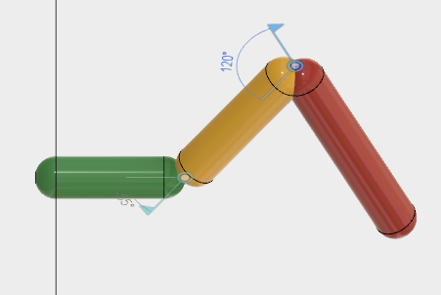 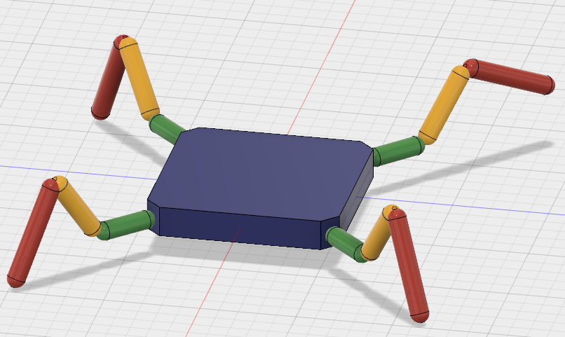

1. **Artificial neural network.**

Artificial neural network(ANN) are nonlinear signal processing networks, which are built by interconnecting multiple artificial neurons, these neurons act as the building block of the ANN. ANN are inspired by biological neural network. It consist of multiple neurons working simultaneously to perform a particular task. ANN learns by example (training). It is parallel distributed processor which stores experiences and make use of it for prediction of new inputs. The artificial neuron consist of multiple parts namely weight, activation function, sigmoidal function, bias and threshold. Learning process of the ANN involves modifying weights in the network layers aiming to achieve expected output, learning process is classified of three types: 1. Supervised learning 2. Un-supervised learning3. Reinforcement learning.

Supervised learning: Process of teaching the ANN by providing with sample input and comparing the error with the expected output. Back propagation, pattern associated memory net are few example of supervised learning.

Un-supervised learning: In an ANN if input training vectors are known but target output is not known. The net modifies such that similar input vector is assigned same output unit. Clustering algorithm is an example of un-supervised network.

Reinforcement learning (RL): if input training vectors are known but target output is not given but instead an indication of whether the output answer is right or wrong. Neural network learn the input output mapping through trial and error for maximizing performance index called reward, also known as reinforcement signal.[clg book]

Environment: The physical surroundings of the robot/system

Agent: agent receives observations from environment & mathematical simulator and return action to them. There are multiple algorithms for agent like Q-learning, SARSA (State-Action-Reward-State-Action), DQN (Deep Q-Network), DDPG (Deep Deterministic Policy Gradient) & Actor-Critic. Each of them have their own ability and used under different circumstances [mit paper].

Policy is mapping from perceived states of environment to actions to be taken when in those states.

Reward signal is sent to the RL agent from environment, it defines the goal in RL. Agent’s role is to maximize total reward in long term. It defines good and bad decisions for agent.

Model (Mathematical Simulator) of environment replicates the environment and makes inferences about how the environment will behave under similar actions, this also helps in planning and deciding the action for possible future situations.

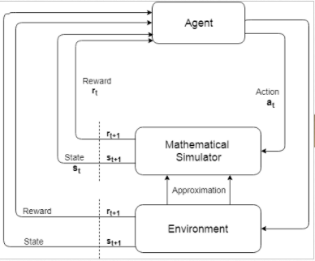

1. **Image and Video Processing:**

Image Processing or Digital Image Processing (DIP) is use of algorithms to enhance and manipulate digital image to achieve particular goal. Images are of two types 1. Grayscale images, these are 2-Dimensional array of data whose pixel value ranges from 0 - 255 for 8 bit point 2. Coloured images, these just like grayscale images but its pixel values are sub-divided into three channels R-G-B (Red-Green-Blue) making it a 3-Dimentional array, each data point in an image is referred as a pixel in DIP , manipulation of these pixel values result in DIP. In practice there are multiple concepts and algorithm to perform image processing, the concept related to the project are image thresholding, masking and finding contours. Image thresholding is a process of converting a given image into binary image, binary image is an image in which all the pixel values are either 0 or 1(i.e. 0 & 255). Thresholding is done in order to achieve a region of interest. For a grayscale image thresholding is given by the equation GIVE NO., where $$ \delta $$ is the threshold value and $$ 0 \ge \delta \le 255 $$.For coloured image three threshold are required i.e. one for each channel, it is given by the equation GIVE NO.

$$ g(x,y) = \left\{\begin{array}{l}f(x,y)\ge \delta ,\, then\,f(x,y) = 1 \\f(x,y) < \delta,\, then\, f(x, y) = 0\end{array}\right.$$ $$f(x,y) = Pixel value $$

$$ g(x,y) = \left\{\begin{array}{l} (R,G,B) \ge (\alpha, \beta, \gamma ) ,\,then\; f(x,y) = (1, 1, 1) \\(R,G,B) < (\alpha, \beta, \gamma ), \, then\, f(x, y) = (0, 0, 0)\end{array}\right.$$

$$ \alpha : Threshold for Red channel$$

$$ \beta : Threshold for Green channel$$

$$ \gamma : Threshold for Blue channel$$

Masking is done to get the ROI (Region of Interest) form the image i.e. making the background of image as zero or some other constant value. The equation GIVE NO. gives the mathematical formulation of mask. Different methods are available to perform masking, for this application we use binary image & original image and do binary operation on these two images, which is given by the equation GIVE NO.

$$ h(x,y) = f(x,y)\wedge g(x,y) $$

$$ h(x,y) : Resultant Image $$

$$ f(x,y) : Original Image $$

$$ g(x,y) : Binary Image $$

Contours are mathematically defined as function of curve in a plane of two or three variables i.e $$ f(x,y,z)\, or\, f(x,y) $$ [cite two books calculus single and mult.. & what is mathematics?..] in DIP domain it is defined as a continuous curve joining continuous points having same pixel intensity value[ https://docs.opencv.org/3.3.1 ]. This enables us to identify the ROI i.e. circle, and find out its properties like area, mean, intensity etc. for further calculation.

“DEMO IMAGES FOR CONTOUR DETECTION BY OUR CODE WITH ORIGINAL IMAGE”